
Agenda Item 9
BI-01-02

CHILDREN AND FAMILY COURT ADVISORY AND SUPPORT SERVICE

Paper for the Board meeting on 19 January 2007

PERFORMANCE REPORT

1 AIM AND PURPOSE

1.1 To provide the Board with an update overview of the operational service position as at 31 October 2006.

2 ACTION FOR THE BOARD

2.1 This report is for information and discussion only.

3 RECOMMENDATION

3.1 For the Board to note the report and key issues.

4 KEY STRATEGIC ISSUES FOR THE BOARD TO CONSIDER

Key Performance Indicators | Target / Norm | Performance | Year to Date
1 – S31 allocations within 2 days | 70% | ☹  | 54.8%
2 – Total allocations within 28 days | 98% | 😐  | 93.5%
3 – Public unallocated | 3% | ☺  | 2.6%
4 – DR’s with full/partial agreement | 55% to 65% |  | 59.4%
5 – DR’s referred for S7 | 35% to 45% |  | 19.4%
6 – Service user diversity | 65% | ☹  | 49.3%
7 – Appraisals completed in 12 mo. | 100% | ☹  | 53.0%
8 – Sickness Absence | 4% | 😐  | 4.1%
A – Private unallocated <10 weeks | 4% | ☺  | 4.0%

Sherry Malik Allison Calvert

Corporate Director, Strategy & Performance Corporate MIS Manager

KPI 1 – 70% of allocations during the month for Section 31 cases (care and supervision) should be within 2 working days from receipt of request (receipt day counted as nought).
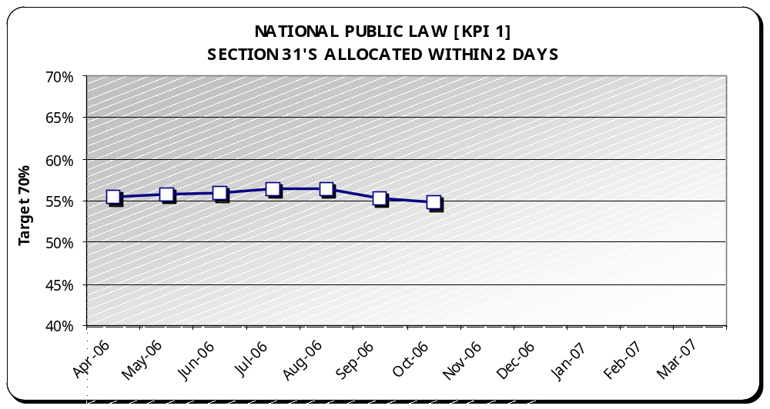 | Target | Performance | Year to Date
 | 70% | ☹ | 54.8%

Analysis
Graph - Year to date performance has fallen slightly from 55.2% to 54.8% as at the end of October.

Best Performance – East Midlands (96.3%)

Regional Hotspots – Greater London (19.3%), North East (34.2%), West Midlands (41%), South East (45.4%), Eastern (51.6%) and Yorks and Humberside (57.3%).

No Performance Changes

Comparison (April through October) - Last year’s performance was 46.9%.

NB: This graph shows the performance each month as a year to date percentage. Year to date percentages are used to build a picture of performance as the year progresses. This is also the most accurate picture given that the Case Management System allows for timely reporting of amendments.

KPI 2 – At least 98% of all public law allocations each month for all case types should be within 28 working days from receipt of request.
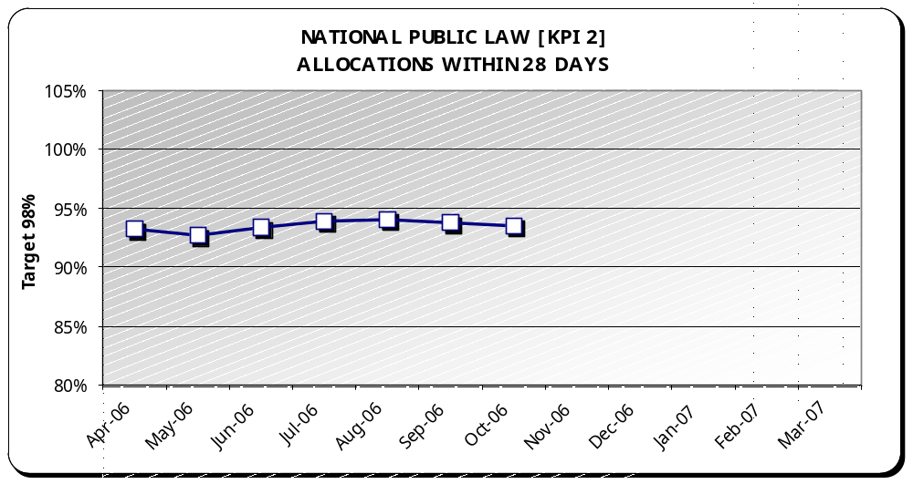 | Target | Performance | Year to Date
 | 98% | 😐 | 93.5%

Analysis
Graph - Year to date performance has fallen slightly from 93.7% to 93.5% as at the end of October.

Best Performance – East Midlands (100%)

Regional Hotspots - North East (80.2%), West Midlands (86%) and Greater London (88.7%).

Performance Changes –
-  North West moved from amber (97.8%) to green (98.2%)

Comparison (April through October) - Last year’s performance was 90.3%.

NB: This graph shows the performance each month as a year to date percentage. Year to date percentages are used to build a picture of performance as the year progresses. This is also the most accurate picture given that the Case Management System allows for timely reporting of amendments.

KPI 3 – No more than 3% of the public law workload should remain unallocated at month end.
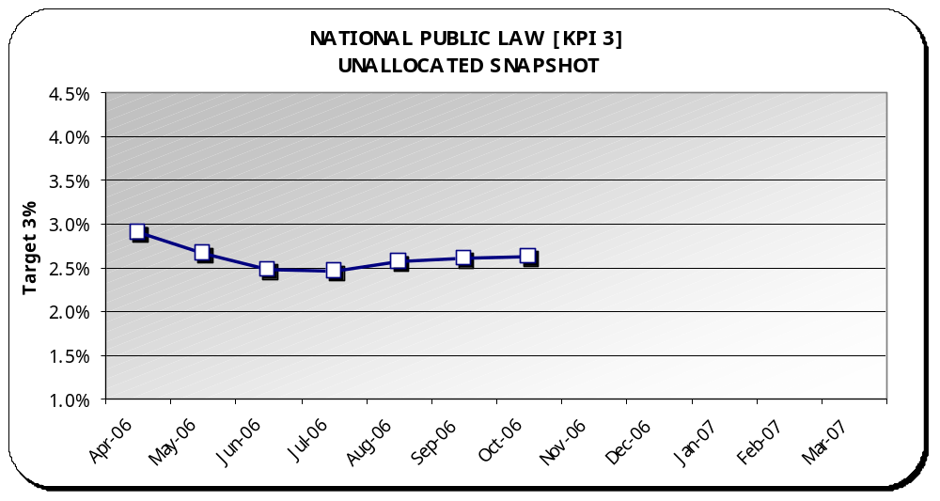 | Target | Performance | Year to Date
 | 3% | ☺ | 2.6%

Analysis
Graph - Year to date performance has stayed the same at 2.6% as at the end of October.

Best Performance – South West (0.4%)

Regional Hotspots - North East (8.1%)

Performance Changes –
 West Midlands moved from red (4.2%) to amber (3.8%)

Comparison (April through October) – Last year’s performance was 2.8%.

Backlog - A low level of unallocated public law cases is being sustained against the target. October’s backlog was 317 cases.

NB: This graph shows the performance each month as a year to date percentage. Year to date percentages are used to build a picture of performance as the year progresses. This is also the most accurate picture given that the Case Management System allows for timely reporting of amendments.

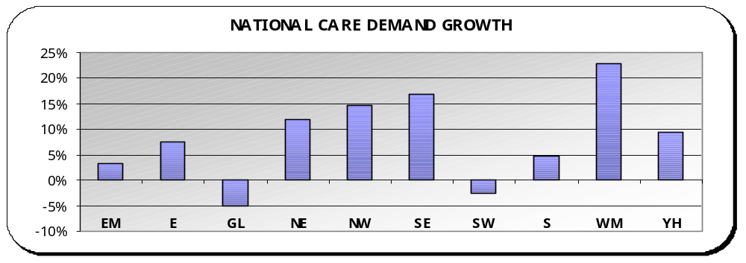 | Public Law demand - In comparing this year to date to the same period last year, Public Law care requests are up 7.6%. Eight regions are showing increases in demand to date compared to the same period last year.  Overall total Public Law requests, when including all types of proceedings, were up 2.6% comparing the same period.  Adoption requests were down 17.2% in same period.
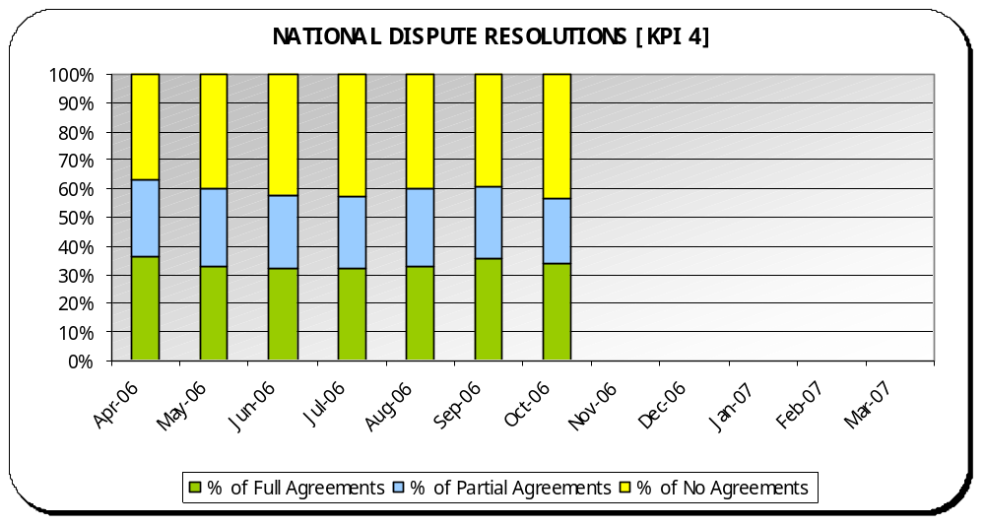
KPI 4 – Percentage of dispute resolutions (including extended dispute resolutions) resulting in full or partial agreement.
 | Norm | Performance | Year to Date
 | 55% to 65% |  | 59.4%

Analysis
Graph - Year to date performance has fallen slightly from 59.8% to 59.4% as at the end of October.

Max – Eastern (73.5%)

Min – North West and South East (54.4%)

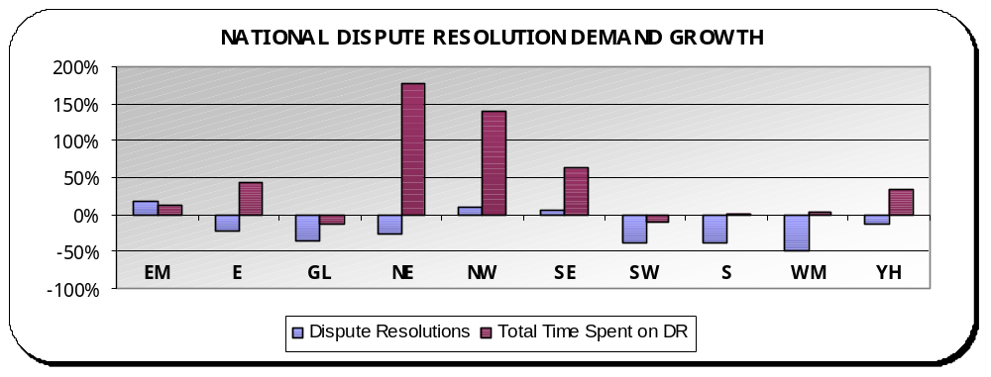 | Dispute Resolutions: In comparing this year to date to the same period last year, Dispute Resolutions are down 20.9%. Three regions are showing increases.  Time spent on Dispute Resolutions are up 8,453 hours compared to the same period last year. This equates to a 35.2% increase with eight regions showing increases.
KPI 5 – Percentage of Section 8’s referred for dispute resolution that are then, referred for a Section 7.
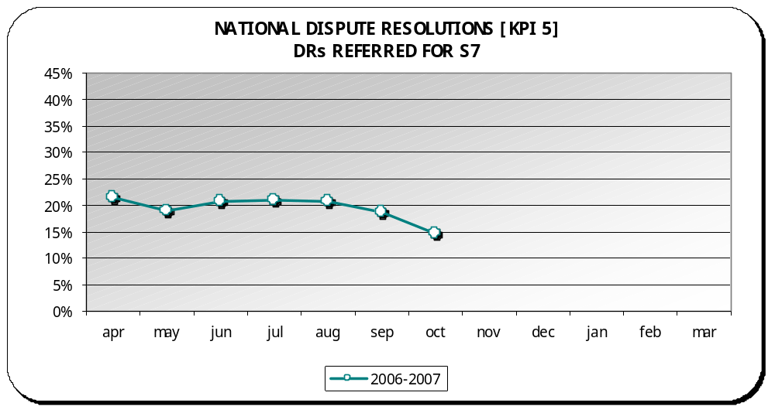 | Norm | Performance | Year to Date
 | 35% to 45% |  | 19.4%

Analysis
Graph - Year to date performance has improved slightly from 20.3% to 19.4% as at the end of October.

Max – South East (27.6%)

Min – Eastern (12%)

NB: This graph shows the performance each month as a year to date percentage. Year to date percentages are used to build a picture of performance as the year progresses. This is also the most accurate picture given that the Case Management System allows for timely reporting of amendments.

NB: Rollout of CMS teams this year – due to the changing work of private law and the subsequent changes required for CMS, KPI 5 for CMS teams is not currently measured and will be unavailable until a new report is completed by our service provider. Once completed, figures will be updated.

KPI 6 – 100% diversity monitoring forms returned for all service users by year-end.
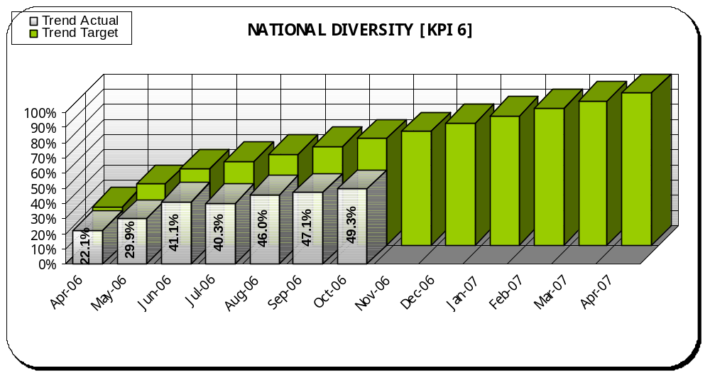 | Interim Target | Performance | Year to Date
 | 70% | ☹ | 49.3%

Analysis
Graph - Year to date performance has improved slightly from 47% to 49.3% as at the end of October.

Best Performance – North East (67.9%)

Regional Hotspots – Greater London (32.7%), North West (36.7%), West Midlands (39.5%), Southern (43.5%), South West (47.8%), South East (50.5%), Eastern (55.6%) and East Midlands (57.4%)

Performance Changes – interim target moved from 65% to 70%
-  North East moved from green (68.7%) to amber (67.9%).
-  Eastern moved from amber (55.1%) to red (55.6%).

NB: This graph shows the performance each month as a year to date percentage against a progressive monthly interim target. Year to date percentages are used to build a picture of performance as the year progresses. This is also the most accurate picture given that the Case Management System allows for timely reporting of amendments.

Diversity: Since the introduction of a new KPI in April of 100% forms returned for all parties and children in new cases by the end of 2006-2007, all regions have been concentrating on improving their returns, and many have action plans in place. While there is a continuing upward trend, nationally we are still not meeting the interim monthly target and this gap is widening. 12.9% of teams are meeting the stretch interim target of 70% for October and another 14.3% of teams were on-target with more than 60% returned.

KPI 7 – 100% appraisals completed for all staff within a 12-month rolling period.
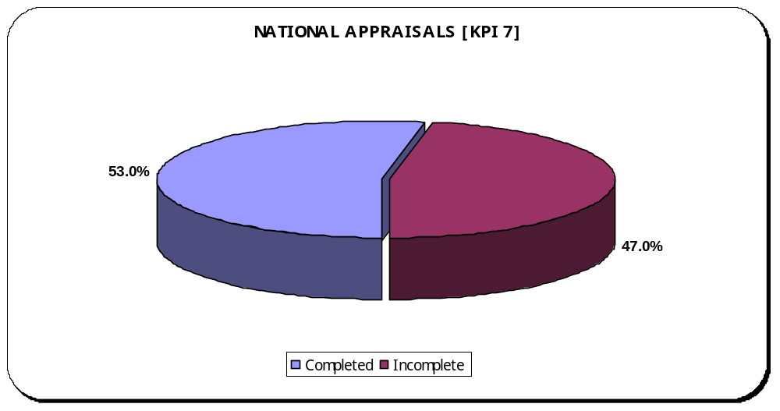 | Target | Performance | Year to Date
 | 100% | ☹ | 53.0%

Analysis
Graph - Year to date performance has improved from 45.9% to 53% as at the end of October.

Best Performance – North East (95.4%)

Regional Hotspots – West Midlands (24.5%), South East (25.9%), Greater London (26.4%), South West (34.5%), National Office including Legal Services (36.6%), Eastern (40%), East Midlands (42.2%), Southern (43.1%), North West (74.1%) and Yorks and Humberside (88.6%).

Performance Changes –
 Yorks & Humberside moved from amber (90.7%) to red (88.6%).

Appraisals: The Quarter 2 regional performance monitoring is currently underway. This KPI and surrounding issues will be scrutinized where performance is low.

KPI 8 – Sickness absence rate of no more than 4% should be maintained.
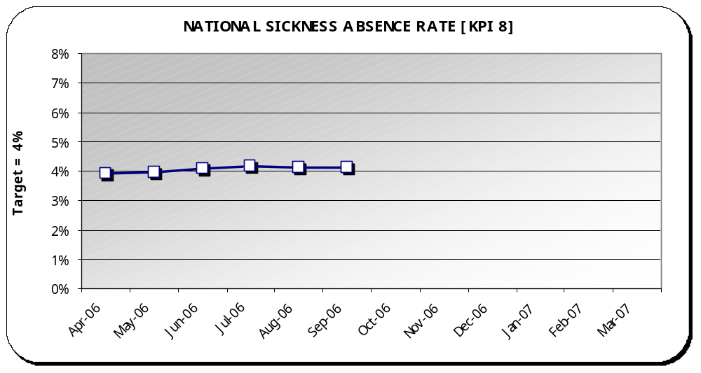 | Target | Performance | Year to Date
 | 4% | 😐 | 4.1%

Analysis
Graph –Year to date performance has stayed the same at 4.1% as at the end of October.

Best Performance – South West (1.6%)

Regional Hotspots – Southern (5.9%) and North West (5.4%).

Performance Changes –
 East Midlands moved from red (5.0%) to amber (4.9%).
 West Midlands moved from red (5.0%) to amber (4.4%).

NB. September figures revised from 3.9% to 4.1%
Workforce: Nationally, sickness absence at 4.1% is on-target to meet 4%. Much of the sickness in the regional hotspots is down to long term sickness of a small number of staff and plans are in hand to address this through occupational health. Increasing demand can also place pressure on a regions capacity. There is still a missing capacity of 37.2 WTE (whole time equivalent) for FCA’s and 4.2 WTE for Service Managers nationally.

Private Law Summary
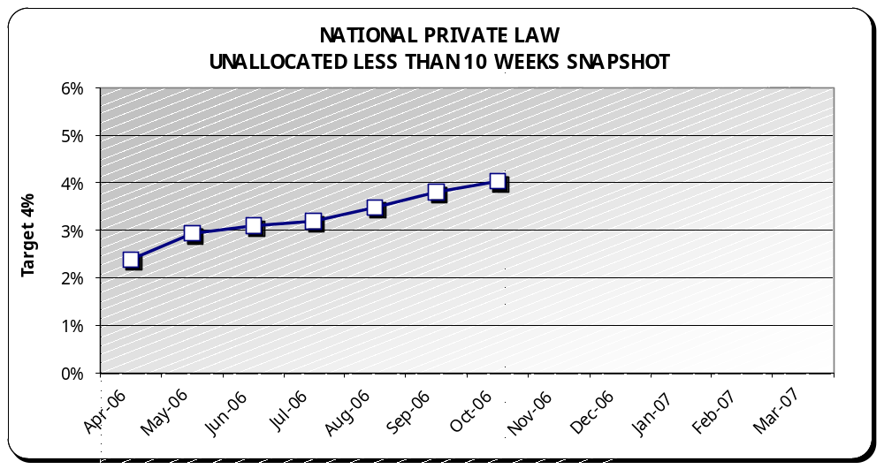 | Target | Performance | Year to Date
 | 4% | ☺ | 4.0%

Analysis
Graph - Year to date performance has fallen from 3.8% to 4.0% as at the end of October.

Best Performance – East Midlands (0.4%)

Regional Hotspots –West Midlands (6.7%) and South East (9.1%).

Comparison (April through October) – Last year’s performance was 3.0%.

Backlog - A low level of unallocated private law cases less than 10 weeks is being sustained. October’s backlog of cases less than 10 weeks was 466 reports. Total unallocated backlog was 1503 reports.

NB: The graph above shows the performance each month as a year to date percentage. Year to date percentages are used to build a picture of performance as the year progresses. This is also the most accurate picture given that the Case Management System allows for up to the minute reporting of changes.

Private Law Summary continued
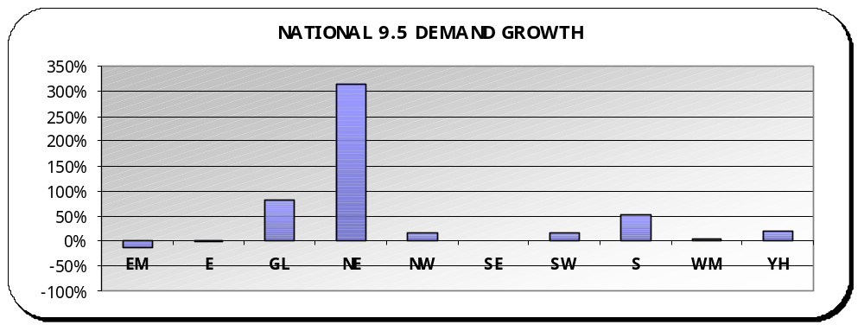 | Private Law demand - Comparing this year to date to last year, Rule 9.5 cases are up 20.5% (122 cases) compared to last year, with eight regions showing an increase.  NB - North East’s increase relates to an increase of 22 cases.  Overall, total Private Law report requests were down nationally 13.0%. All regions are reflecting this downward trend in total private law reports except for South East who had a 1.1% increase.  Family Assistance Orders - In comparing this year to date to the previous year, FAO’s are down 18.2% (74 orders). Yorks & Humberside is the only region with an increase (23 orders).
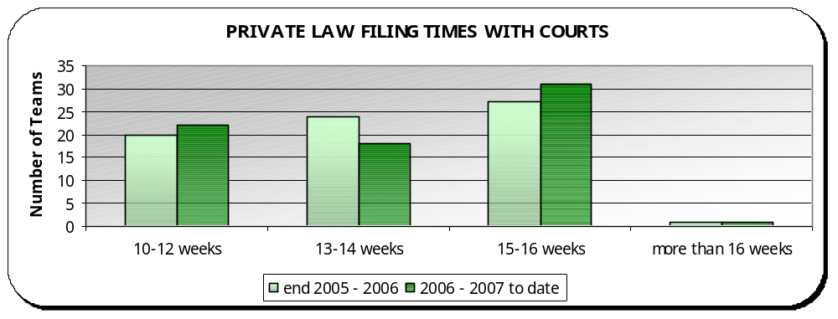 | Private Law Court Filing Times - 30.6% ☺ of teams meet the standard filing time of 10–12 weeks, 26.4% 😐 of teams are on target to meet the standard with 13–14 weeks, 40.3% of teams have filing times of 15–16 weeks ☹ and 2.8% of teams are filing more than 16 weeks ☹ (2 teams). These are Slough (23 weeks) and Lancaster (26 weeks).  Performance Changes – (in weeks)  -  Cheshire (from 15-16 to 10-12)  -  West Kent (from 16 to 14)  -  Lancaster (from 16 to 26)  -  Avon (from 14 to 16)  -  Oxford (from 12 to 13)

Finance Summary
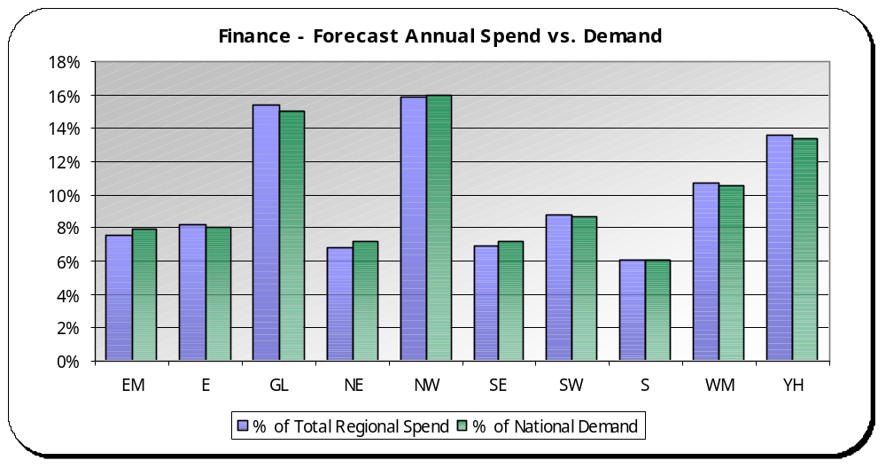 | Analysis  Overall, there is a strong correlation between resource use and activity with no real significant outliers.  Max – North East is within resources undertaking 7.2% of the work and using 6.8% of the resources.  Min – Greater London is using a greater percentage of resources compared to their share of demand activity.

NB: Forecasts are produced quarterly and activity is calculated monthly based on a rolling 12-month period.

Finance: This graph compares each region’s use of resources compared to their demand activity.

The percentage of spend is calculated by taking the regions quarter 2 forecast spend as a percentage of total regional forecast spend at quarter 2. The percentage of demand activity is calculated by taking the regions total rolling 12-month demand activity (as at October 2006) as a percentage of total national demand activity (as at October 2006).

It is expected that these two percentages should equal.

